**Task 01**

INCLUDE IRVINE32.INC

.data

array byte "The product of the number you entered by 21 is ",0

var dword 0

.code

main PROC

mov eax, 0

mov ebx, 0

mov ecx, 0

mov edx, 0

mov esi, 0

call readint

mov ebx, eax

shl eax, 4

mov edx, eax

mov eax, ebx

shl eax, 2

add edx, eax

mov eax, ebx

shl eax, 1

add edx, eax

mov eax, edx

mov edx, offset array

call writestring

call writedec

call Dumpregs

main endp

end main

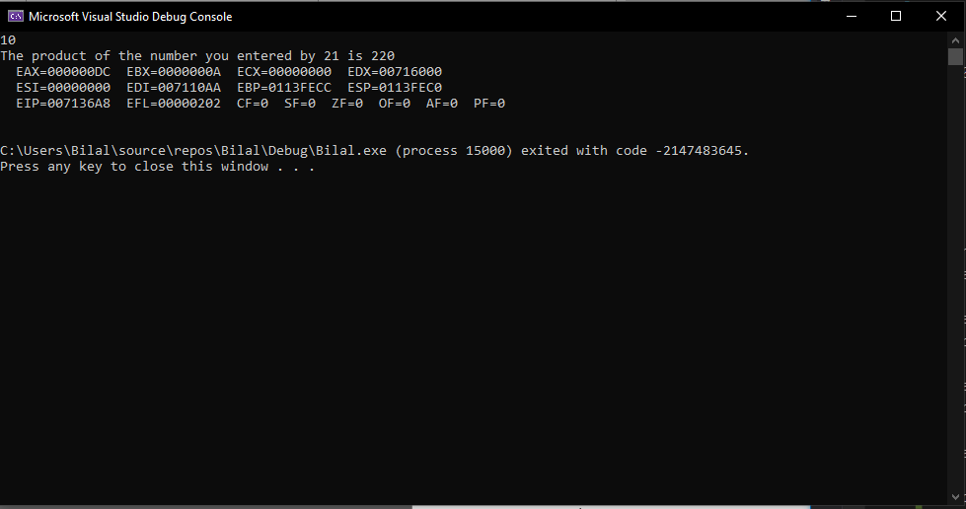

**Task 02**

INCLUDE IRVINE32.INC

.data

array byte "The value initially in the eax when -128 is put in the ax only ",0

array1 byte "The value in eax after shifting ax values in the eax ",0

var dword 0

.code

main PROC

mov eax, 0

mov ebx, 0

mov ecx, 0

mov edx, 0

mov esi, 0

mov ax, -128

mov edx, offset array

call writestring

call writebin

call crlf

mov edx, offset array1

call writestring

shl eax, 16

call writebin

call Dumpregs

main endp

end main

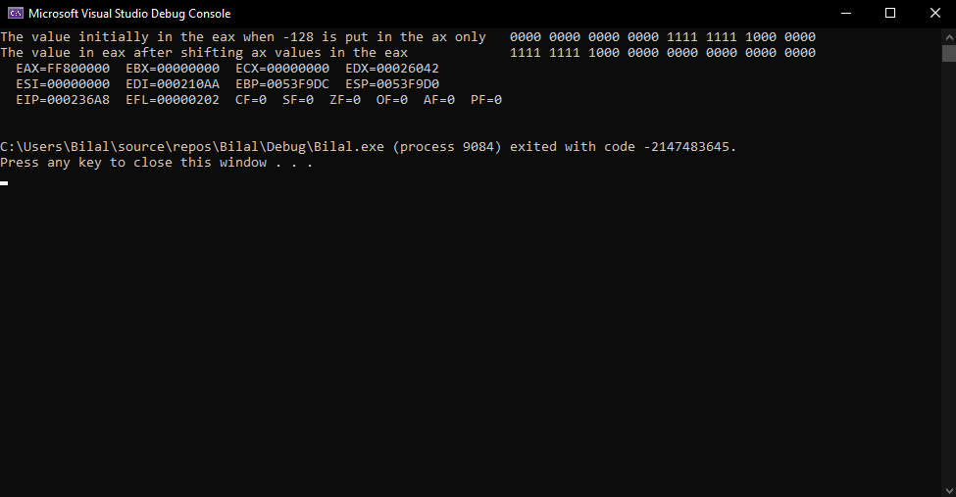

**Task 03**

INCLUDE IRVINE32.INC

.data

array byte "The number of minutes in the given value is ",0

array1 byte "The value of the number you entered in binary form is ",0

fullstp byte ".",0

bMinutes word 0

.code

main PROC

mov eax, 0

mov ebx, 0

mov ecx, 0

mov edx, 0

mov esi, 0

call readint

mov edx, offset array1

call writestring

call writebin

call fullstop

call crlf

shl ax, 5

;call writebin

;call crlf

shr eax, 10

;call writebin

mov bMinutes, ax

mov edx, offset array

call writestring

call writedec

call fullstop

call Dumpregs

main endp

fullstop proc

mov edx, offset fullstp

call writestring

ret

fullstop endp

end main

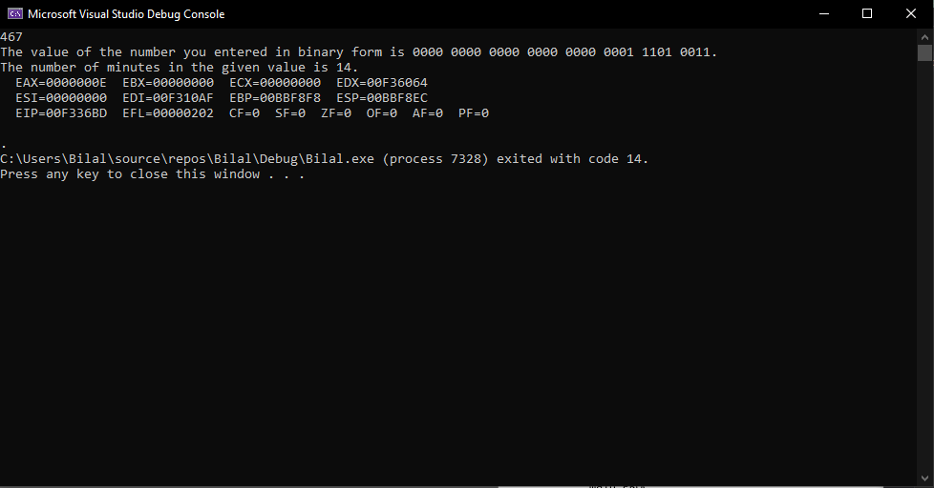

**Task 04**

**Part 01**

INCLUDE IRVINE32.INC

.data

array byte "The least significant bit of ax ",0

array1 byte "Least Significant bit of ax converted into most significant bit of bx ",0

bMinutes word 0

.code

main PROC

mov eax, 0

mov ebx, 0

mov ecx, 0

mov edx, 0

mov esi, 0

mov eax, 0001b

mov edx, offset array

call writestring

call writebin

call crlf

mov ebx, eax

ror bx, 1

mov eax, ebx

mov edx, offset array1

call writestring

call writebin

call Dumpregs

main endp

end main

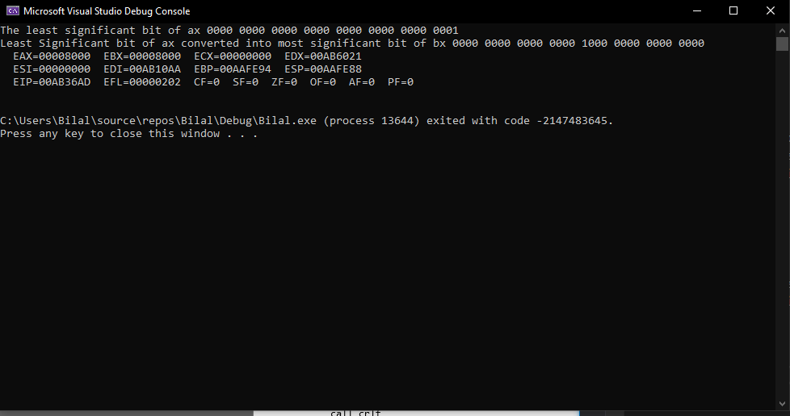

**Part 02**

INCLUDE IRVINE32.INC

.data

array byte "The least significant bit of ax ",0

array1 byte "Least Significant bit of ax converted into most significant bit of bx ",0

bMinutes word 0

fullstp byte ".",0

.code

main PROC

mov eax, 0

mov ebx, 0

mov ecx, 0

mov edx, 0

mov esi, 0

mov eax, 0001b

mov edx, offset array

call writestring

call writebin

call fullstop

call crlf

shrd bx, ax, 1

mov eax, ebx

mov edx, offset array1

call writestring

call writebin

call fullstop

call crlf

main endp

fullstop proc

mov edx, offset fullstp

call writestring

ret

fullstop endp

end main

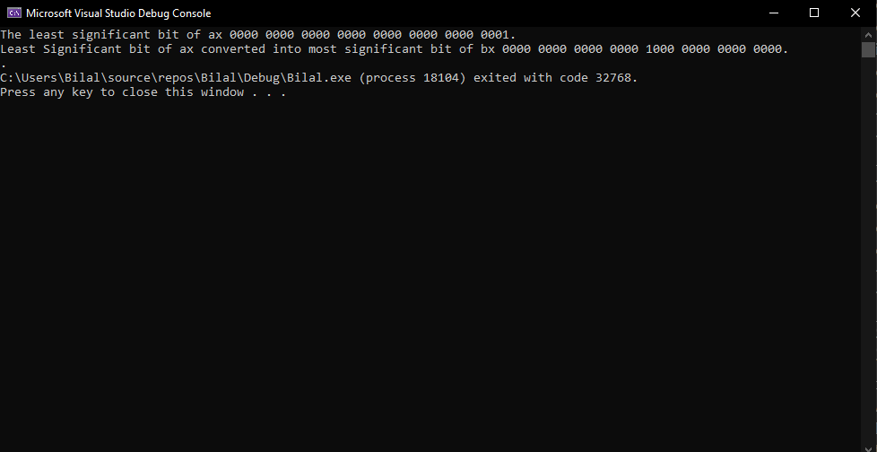

**Task 05**

INCLUDE IRVINE32.INC

.data

array1 byte "Enter the value of val 1", 0

array2 byte "Enter the value of val 2", 0

array3 byte "Enter the value of val 3", 0

val1 word 0

val2 word 0

val3 word 0

Quo1 word 0

Quo2 word 0

message byte "The value of val1 after val=(val2/val3)*(val1/val2) is ",0

.code

main PROC

mov eax, 0

mov ebx, 0

mov ecx, 0

mov edx, 0

mov edx, offset array1

call writestring

call crlf

call readint

mov val1, ax

mov edx, offset array2

call writestring

call crlf

call readint

mov val2, ax

mov edx, offset array3

call writestring

call crlf

call readint

mov val3, ax

mov edx, 0

mov ax, val2

mov bx, val3

div bx

mov Quo1, ax

mov ax, val1

mov bx, val2

div bx

mov Quo2, ax

mov ax, Quo1

mul Quo2

mov edx, offset message

call writestring

call writedec

call dumpregs

main endp

end main

